CSD3205 Advanced Web Development with Big Data

Coursework one – project proposal

Jovanie Lawrence

2018

Table of contents

Introduction ………………………………………………………………………………………………………. 2

Wireframes ……………………………………………………………………………………………………….. 3-5

List of website URLs …………………………………………………………………………………………… 6

Database Diagram ……………………………………………………………………………………………… 7

SQL commands …………………………………………………………………………………………(see attached file)

Conclusion ………………………………………………………………………………………………………… 8

**Introduction**

The idea is to create a price comparison website that compares the prices of the most popular mobile phones(smartphones in particular) in the country. I will use my imagination and creativity to create a wonderful website with a professional design worthy of industry standard. The user will be able to search for particular phones or keywords, that will subsequently bring result from the database matching the users’ search(s). If there is no results found in the database then a suitable message will appear.

This guide will include wireframes of selected pages and will show initial designs. I will also provide a description of each wireframe and its provisional functionalities.

I will enclose diagrams of the database that I will use. I will use [www.dbdesigner.net](http://www.dbdesigner.net) which is a website to assist will intricate designs of database tables. I will provide the screen shots of the designs, which are all done in SQL.

The SQL file that I will use for the website will be included, showing the SQL commands that will help to create the database. This will be included in a zip folder which will include database MySQL dump files of each table in the database.

**Wireframes**

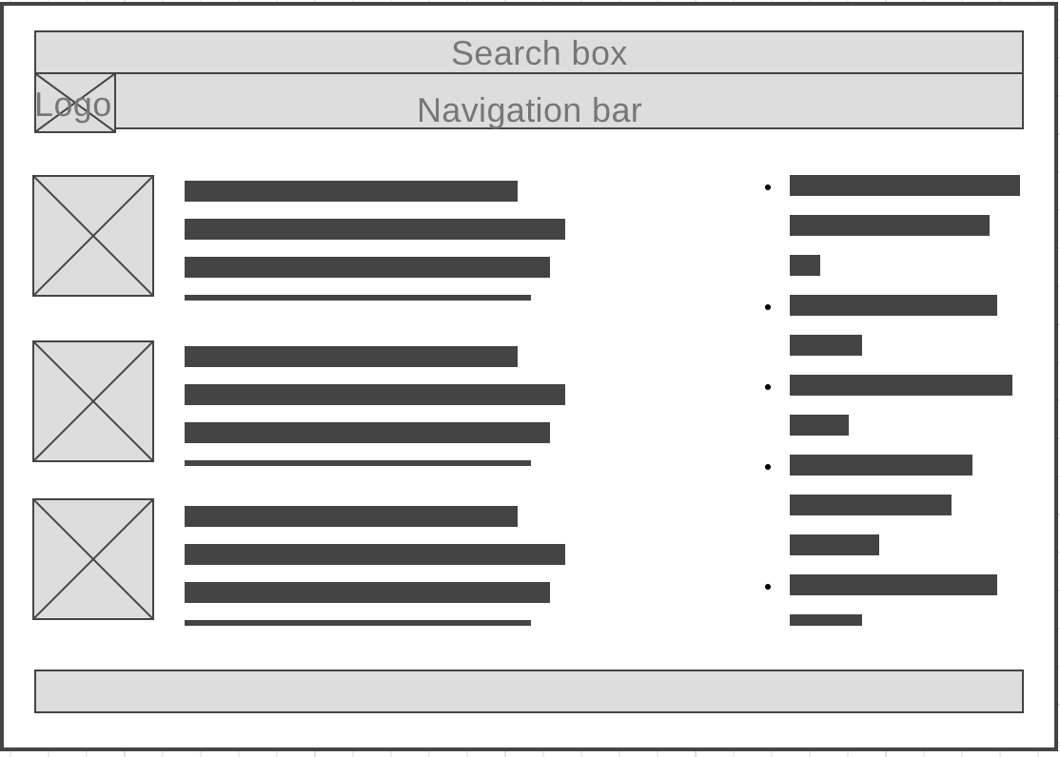

Figure : Homepage

The above wireframe shows the intended homepage of the price comparison website. The navigation bar and search box will be present on each page. Moreover, the logo will be attached to the navigation bar on each page.

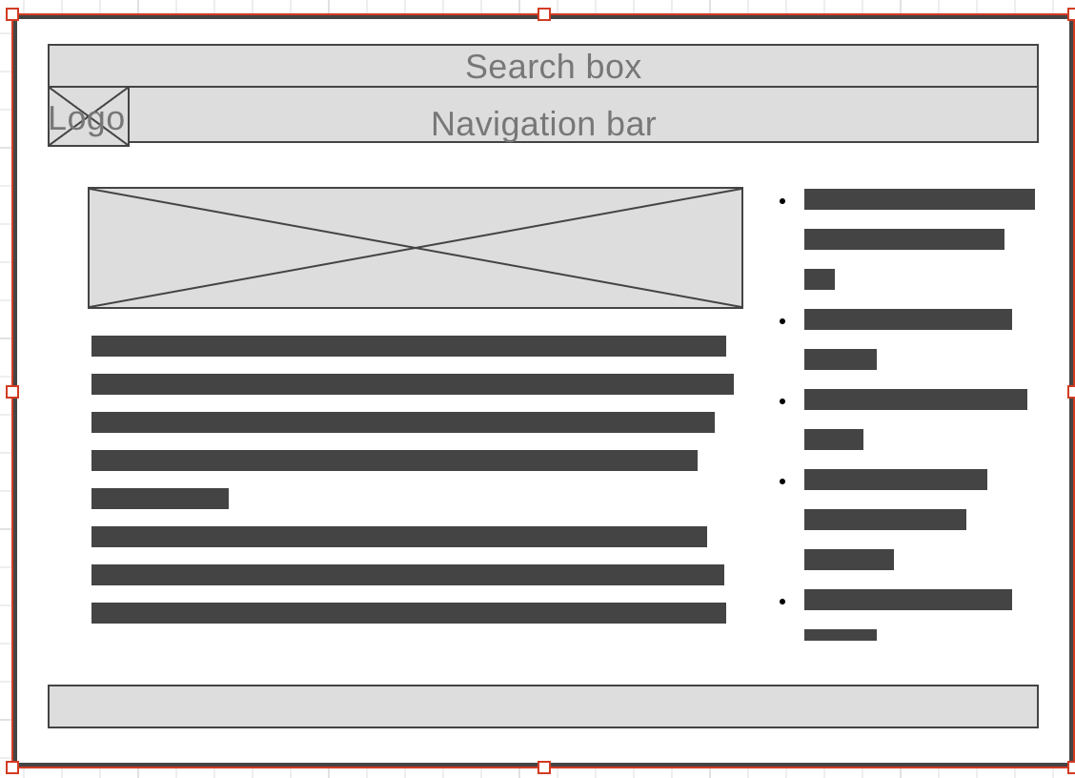

Figure : Manufacturer page

This page show all the possible manufactures’ phones that the website is comparing. Apple, Samsung etc.

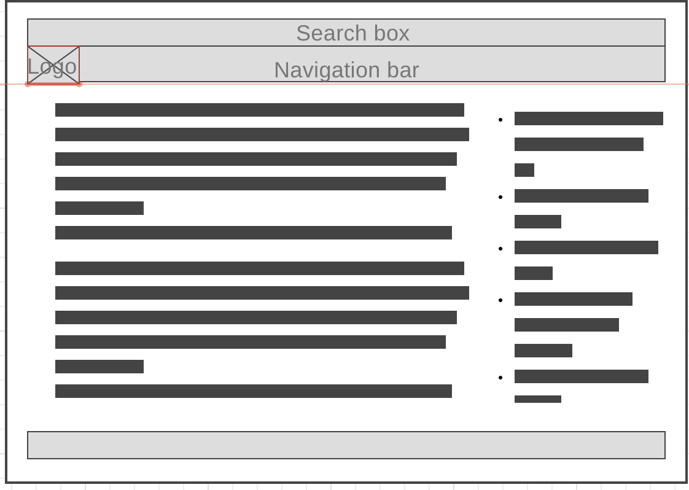

Figure : About

The above wireframes shows the “about” page that will give a description about the website information and description.

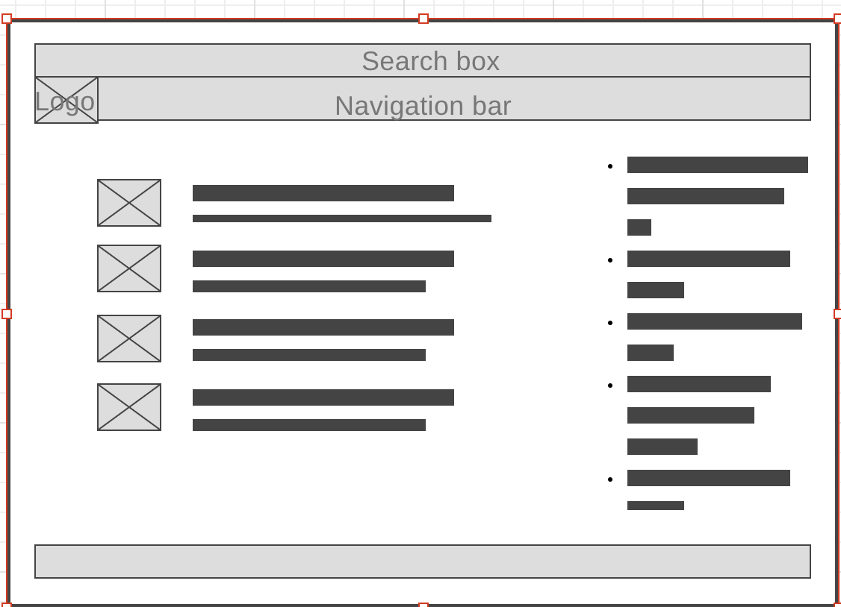

Figure : Search results page

Once the user types something in if the search is successful, the results will be displayed on this page. However, if there is nothing in the database marching the user’s search, then an error message will be displayed stating “No search results found”.

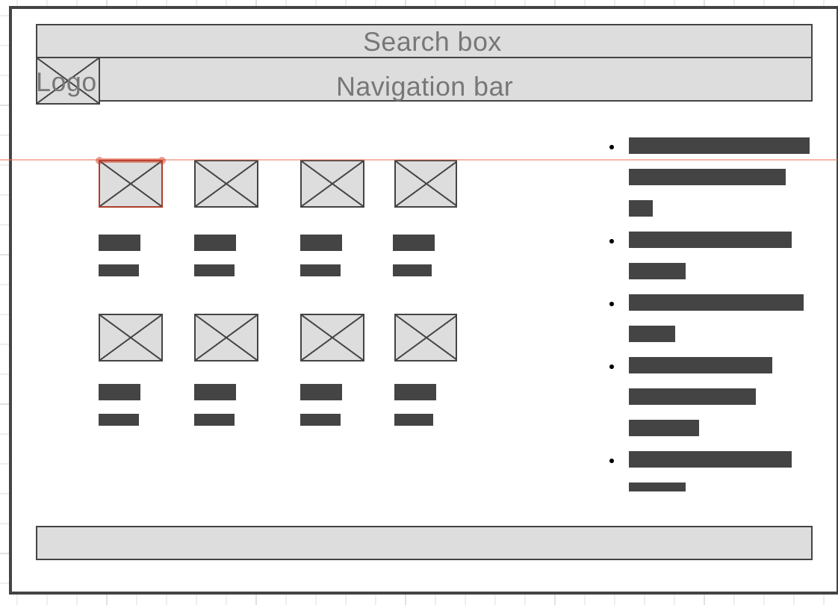

Figure : Contact/feedback

This page will have the contact information on it so the users can get in touch should they need to. Alternatively, they can leave constructive feedback.

List of websites

These are some of the website will be featured on my site that I will be scrapping information from. I double checked the robot.txt file of these URLs and they are fine with curtain information being collected from their websites. In addition, I also collected the idea of these site from other popular price comparison websites that I trust who were scrapping from them.

Amazon

<https://www.amazon.co.uk>

John Lewis

<https://www.johnlewis.com>

Ebay

<https://www.ebay.co.uk>

Currys/Pcworld

<https://www.currys.co.uk>

Very

<https://www.very.co.uk>

Ebuyer

<https://www.ebuyer.com>

Appliances Direct

<https://www.appliancesdirect.co.uk>

Virgin Mobile

<https://www.virginmedia.com>

Carphone warehouse

<https://www.carphonewarehouse.com>

Envirofone

<https://shop.envirofone.com>

I plan to use more URLs to scrap the information I require for my price comparison website. I will include more later in the project once I checked the Robot.txt file of those sites.

Database Design

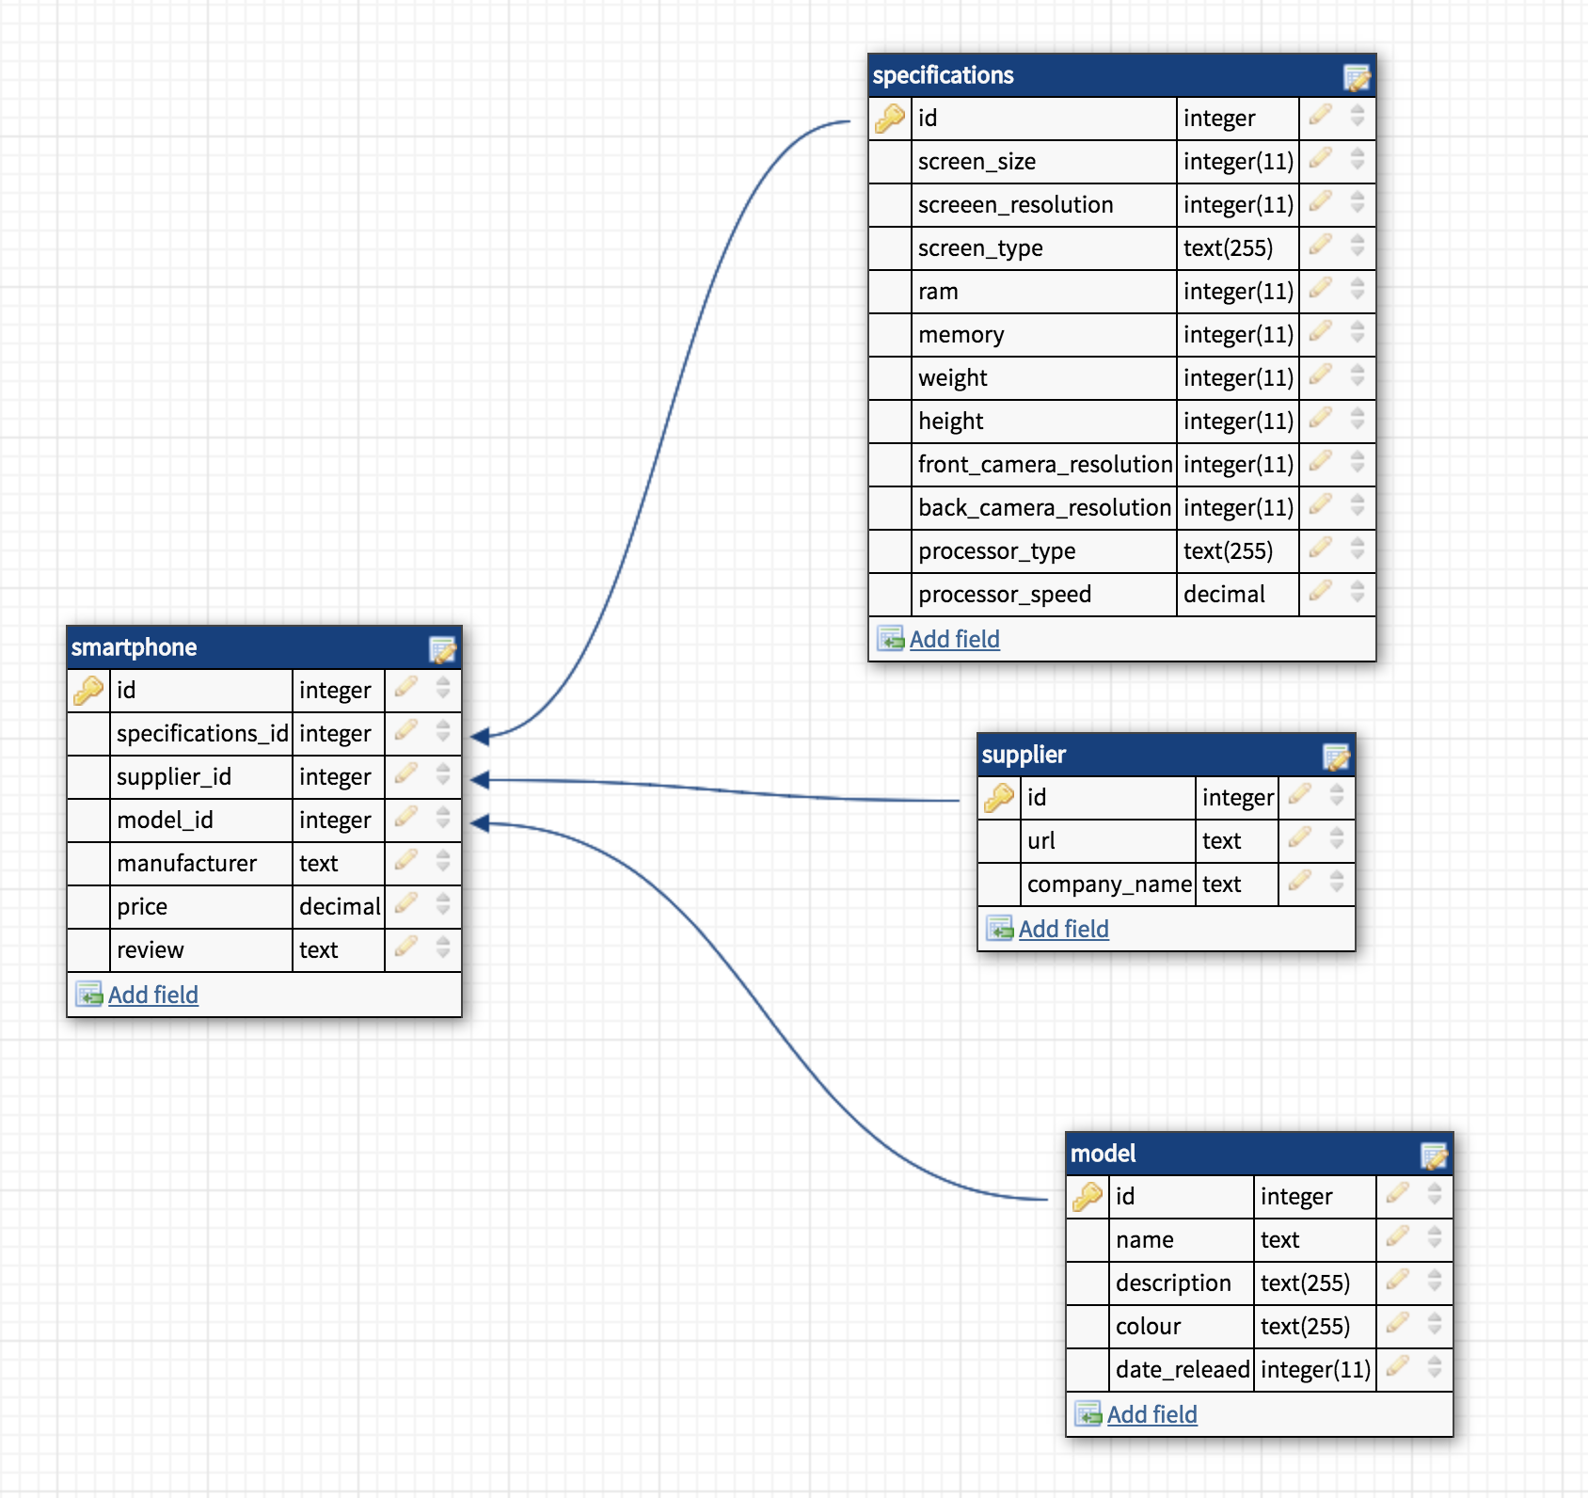

Figure : Database design

The database tables were drawn using a sophisticated software online. It shows the tables with the name and primary and foreign keys of each table. The primary key will make it easier and more professional to find things in the database. The foreign keys shows the relationship between table two tables.

Conclusion

The planning of the website took care and consideration. There are many different ways to do a proposal. The research done was immense and I had major problems try to make the MySQL to work. I finally figured out a solution I removed Xampp completely and installed Mamp. I then used the myphpadmin on the localhost to create MySQL database tables.